Cultural Evaluation Fundamentals Workbook
Table of contents
Introduction 2
Week 1: Evaluation in the cultural sector 2
Activity 1: Defining evaluation 2
Activity 2: Principles of evaluation 4
Activity 3: Evaluation frameworks 6
Week 2: Putting evaluation into practice 8
Activity 4: Evaluation methods 8
Activity 5: Creating your evaluation plan 12
Activity 6: Communicating and learning from your evaluation 14

Introduction
Throughout this course you will be learning about the different elements, principles and tools of evaluation. You will make use of this workbook to complete various exercises and activities created to assist you in developing an evaluation plan.

Week 1: Evaluation in the cultural sector
The activities and exercises in this section of the workbook, revolves around the concepts you learn about during Week 1 of the course. Through these exercises you will have the opportunity to actively explore and reflect on the role, value and common challenges that you experience with evaluation in the cultural sector. You will also get an opportunity to explore your own strengths and challenges with evaluation principles that apply to your context and develop frameworks that will be beneficial to you in your practice of cultural evaluation.

Activity 1: Defining evaluation

Step 1.6: Purpose for evaluation and outlining challenges
Now that you’ve been introduced to the role and value of evaluation in the cultural sector, and seen some of the most common challenges experienced in the industry, it is time to reflect on and identify the purpose and role of evaluation in your own context.
Question | Your answer
Key aim: Why do you want to evaluate? | Enter your answer here
Key questions to address: What value do you want to demonstrate? | Enter your answer here
Key audiences: Who do you want to share the findings with? | Enter your answer here
Challenges: What are your main evaluation challenges? | Enter your answer here
You will refine these through the course, so just capture your key ideas now.

Activity 2: Principles of evaluation

Step 1.11: Evaluation strengths and barriers
Applying the principles of evaluation can be quite challenging at times. Now that you have a better understanding of the different principles and how they underpin good evaluation practice, it is time for you to reflect on where your evaluation strengths and challenges are.
Question | Your answer
- Add a copy of your evaluation star diagram here | Example:  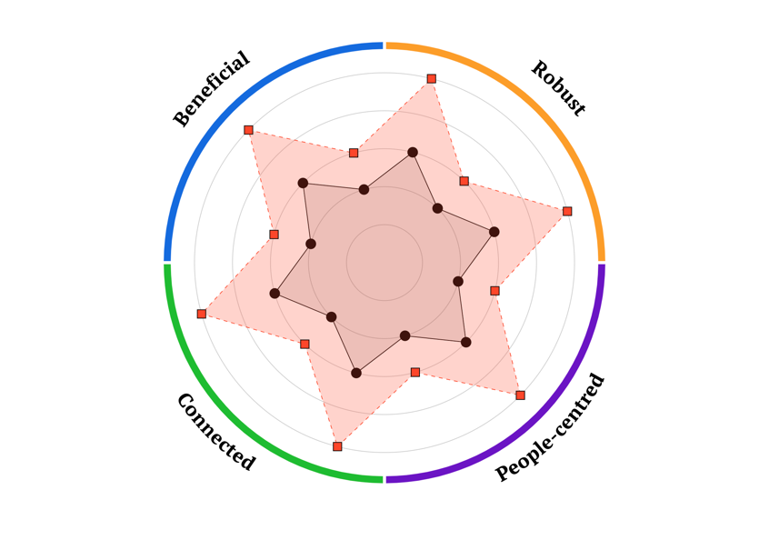
- Where do you think your evaluation strengths lie? What were the top three highest-scoring principles on your chart? | Enter your answer here
- What were the three lower-scoring principles on your chart? Are these areas of the evaluation principles do you want to focus on? | Enter your answer here

Activity 3: Evaluation frameworks

Step 1.16: Populating evaluation frameworks
In this activity you have been introduced to evaluation frameworks, and learned how these frameworks can be used to provide structure to evaluation. Now it is time for you to practise designing your own basic framework.
Using the template framework provided, think of a real-world example, or a project, and populate your framework. You can refer to the downloadable attachment found in Step 1.12: Evaluation frameworks (A 5-step Framework) to complete this activity.
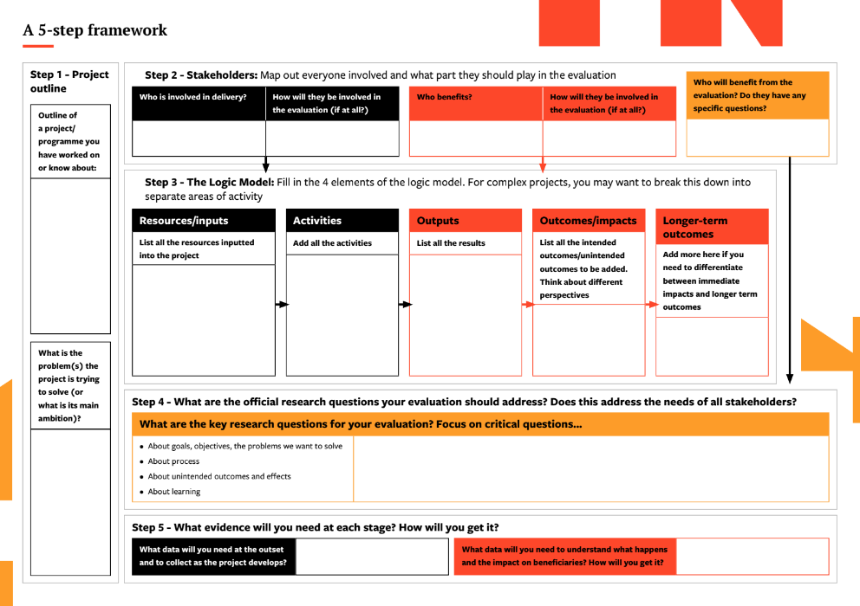

Week 2: Putting evaluation into practice
The activities and exercises in this section of the workbook, revolves around the concepts you learn about during Week 2 of the course. You will get more hands-on with creating your evaluation plan, as you explore evaluation methods and develop your own evaluation plan. You will also have an opportunity to consider how your organisation will learn from the evaluation.

Activity 4: Evaluation methods

Step 2.2: Applying evaluation methods

Effective evaluation checklist
Part of the skill of effective evaluation is knowing what will be most useful, and what will be enough, to support your learning. For some key questions to think about, refer to the attached checklist.
Question | Done (Yes/No)
- Do you have a clear (and agreed) definition of what you are evaluating, and what you want the evaluation to achieve? | Yes/No
- Do you know all specific measures that are required by stakeholders (all those with a ‘stake’ in the activity - including participants as well as funders)? | Yes/No
- Do you have ways to gather them? | Yes/No
- Do you know what context you should be comparing to? | Yes/No
- Do you have ways of collecting the necessary contextual information? (E.g., Do baselines already exist?) | Yes/No
- Do you understand what ‘good practice’ looks like for the evaluation methods you have chosen? | Yes/No
- Do you understand what claims your evidence can meaningfully support? (And which it can’t?) | Yes/No
- Do you have the skills necessary to deliver your chosen methods? (Or ways to get them?) | Yes/No
- Have you acknowledged the limitations of the approach you have taken? | Yes/No

Step 2.5: Using mixed methods
Now that you’ve discovered some of the most effective and innovative cultural evaluation methods, it is time for you to explore how you might use them to ensure your evaluations are robust and ethical, and also increase your confidence in combining and using these evaluation methods.
Question | Your answer
- In which situations are mixed methods most valuable? | Enter your answer here
- Why might you decide not to do mixed methods evaluation? | Enter your answer here
- What are the advantages of different combinations of the methods discussed? | Enter your answer here
- What are the benefits of doing different methods in different orders? (E.g., A focus group then a survey; or a survey then a focus group?) | Enter your answer here
- When you write up mixed methods research, do you think you should report the different methods together, or separately? | Enter your answer here

Activity 5: Creating your evaluation plan

Step 2.12: Refine your evaluation plan
It is time to bring together all the elements that you have learned about in this course, and start creating a realistic and achievable evaluation plan. You could already have started drafting some of these elements throughout the course, and this will be the ideal space to bring it all together.
Refer to the evaluation plan you have created and review it asking yourself the following questions:
Question | Your answer
- Is the purpose and overall research question clear and relevant? What changes could you make so that it is clearer? | Enter your answer here
- How does your plan relate to the evaluation principles? Is your evaluation plan Beneficial, Robust, People-Centred, and Connected? What changes could you make so it demonstrates these principles more fully? | Enter your answer here
- Does the framework or approach you are using align with the purpose of your evaluation? Is there a good fit? What changes do you feel you need to make to better align your framework with the purpose of your evaluation? | Enter your answer here
- Are your evaluation methods appropriate and relevant? Will they obtain the evidence you need? What improvements could you make? | Enter your answer here
- When you write up mixed methods research, do you think you should What ethical considerations do you need to think about in your evaluation plan? Add these to you your plan. | Enter your answer here

Activity 6: Communicating and learning from your evaluation

Step 2.11: Communicating findings
You now have a body of evidence, insight and learnings to share with your stakeholders. In this step you will plan how to tailor the findings to the specific needs and priorities of those stakeholders.
Look at the following table and complete the information for each one of your stakeholder groups.
Group number | List your stakeholders, one per row, taken from the 1:14 Stakeholder Mapping Exercise | What do they need the information for? | What are their priorities? | List the findings that would be most useful and relevant to them | Consider the best ways of presenting that information
1
2
3
4
5

